SUBTRACTION UP TO 10
KS1 – 2002 Paper
1.
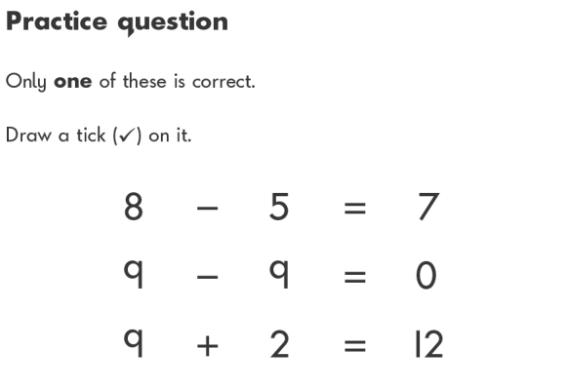
KS1 – 2016 Paper - Arithmetic (Second)
2.
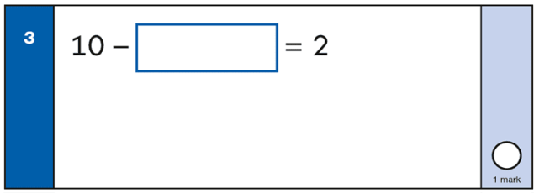

KS1 – 2017 Paper – Arithmetic
3.
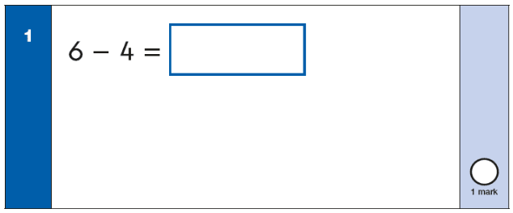
KS1 – 2017 Paper – Arithmetic
4.
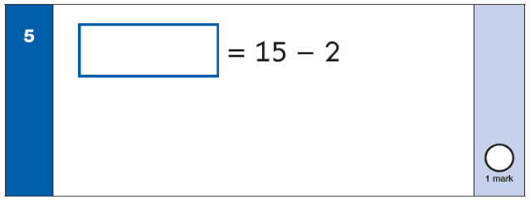
KS1 – 2019 Paper – Arithmetic
5.

